Sources of data for Bugatti EB110 (GT)

*Version 0.11 alpha (for Assetto Corsa) 2022-01-11*

## Fair Use Notice

This document may contain copyrighted material the use of which has not always been specifically authorized by the copyright owner. We are making such material available in an effort to discuss, provide general information and express personal opinion about the material. We believe this constitutes a 'fair use' of any such copyrighted material as provided for in section 107 of the US Copyright Law. In accordance with Title 17 U.S.C. Section 107, the material on this site is distributed without profit to those who have expressed a prior interest in receiving the included information for research and educational purposes. For more information go to: <http://www.law.cornell.edu/uscode/17/107.shtml>.

If you wish to use copyrighted material from this document for purposes of your own that go beyond 'fair use', you must obtain permission from the copyright owner.

If you are the representative or owner of the copyrighted material that appears in this document and have any issue with the way your material is made available in this document, please contact the Authors immediately and we will remove any of your material as soon as reasonably possible.

Main reason for embedding the linked source data into this document is to ensure that the references are not lost over time on the Internet and provide a way to review the original sources.

## Important notes about Data sources

To correctly interpret the data sources please consider this:

1. **Not all EB110 cars of the same model are equal.** Some differences are only cosmetic (mirrors, rear logo, etc.), some things stayed the same (gear ratios) but the engines and suspension may differ. For example according to [EB110_Registry](http://yo.spc.free.fr/EB110_Registry.htm) the GT had two standard engine power outputs: “The GT version was powered with a 550 bhp V12 quadriturbo engine (+10 bhp engine evolution later).”
2. Bugatti was always a small company that used every available car/chassis they had to continuously develop the EB110. That means:
   1. **In some cases media was given upgraded cars for test drives.** Bugatti test cars and press cars are the same thing. For example a GT test-car may have been equipped with an engine that was in development for the SuperSport and the reviewers did not know that.
3. **Do not believe official performance certification data.** This is not limited to Bugatti, but most official performance certifications involve some unrealistic car preparation. Especially when world records are at stake. For example Bugatti record runs were done with only one mirror and duct-tape over all body gaps for better aerodynamics; the cars had minimal interior trim and maybe even engine modifications.
4. Official **specification sheets are not 100% reliable**. There are examples of basic numbers that are different from one Bugatti spec sheet to another.
   1. Marketing always tries to make numbers look as great as possible. For example, they may use theoretical, not actual values.
   2. As mentioned models evolved over time or there are simply mistakes in the published data.

Based on all the information above here are some data sources that are **quite reliable:**

* Sport Auto, n375 (May 1993, France) – very detailed independent test of EB110GT which performed as expected.
* Car Graphic, Road Test No.345 (199?, Japan) – the most precise independent performance measurement of EB110GT using a production model.
* Auto Motor und Sport, (May1993, Germany) – also detailed independent test of EB110GT which performed as expected.
* Factory data on certain components: gear ratios, suspension geometry and wheel alignment + other numbers that are likely to be correct.

Known independent tests that have **problematic data:**

* Road and Track, (July 1994, USA) – the GT car supposedly had non-standard 611 bhp engine and still showed very poor 0-60 mph performance.
* Gente Motori, (Aug1993, Italy) – the test car was likely too powerful for a normal GT spec.

## Sources of Data

Here is a list of all data that is needed, what values are used right now and the data sources. Please fill in any missing information.

#### GT Spec sheet

Source: <http://yo.spc.free.fr/Bugatti%20register/EB110_GT/EB110GT.htm>

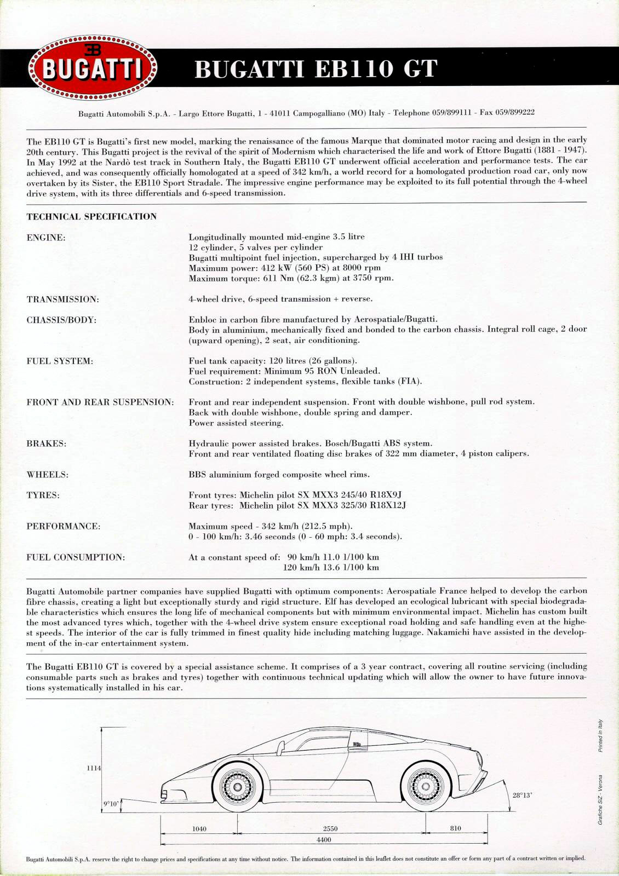

#### SS Spec sheet

Source: <http://yo.spc.free.fr/Bugatti%20register/EB110_Supersport/EB110SS.htm>

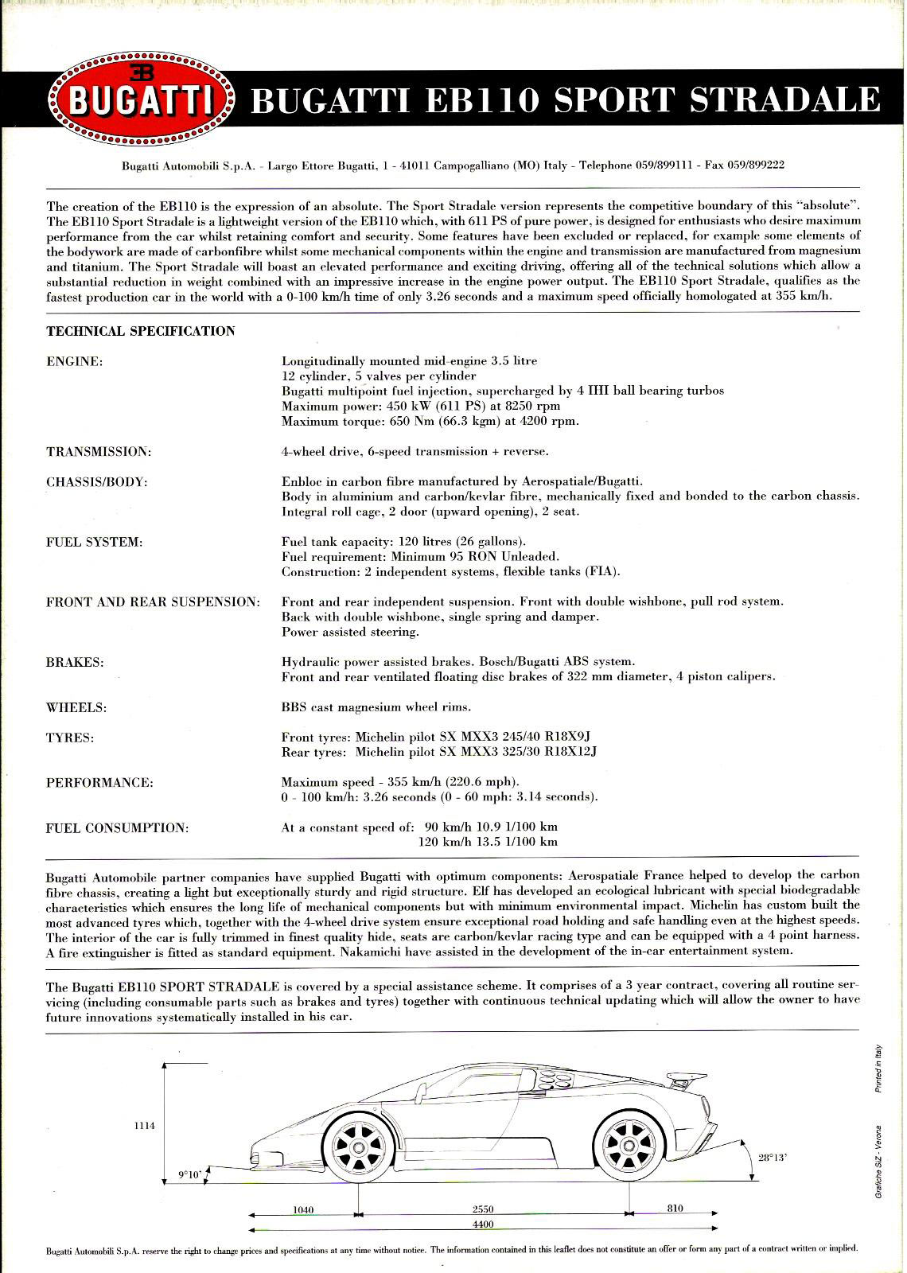

#### S Spec sheet (early version of SS)

Source: <https://www.deviantart.com/pzlwksmedia/art/EB110-Tech-P1-Web-3-364234236>

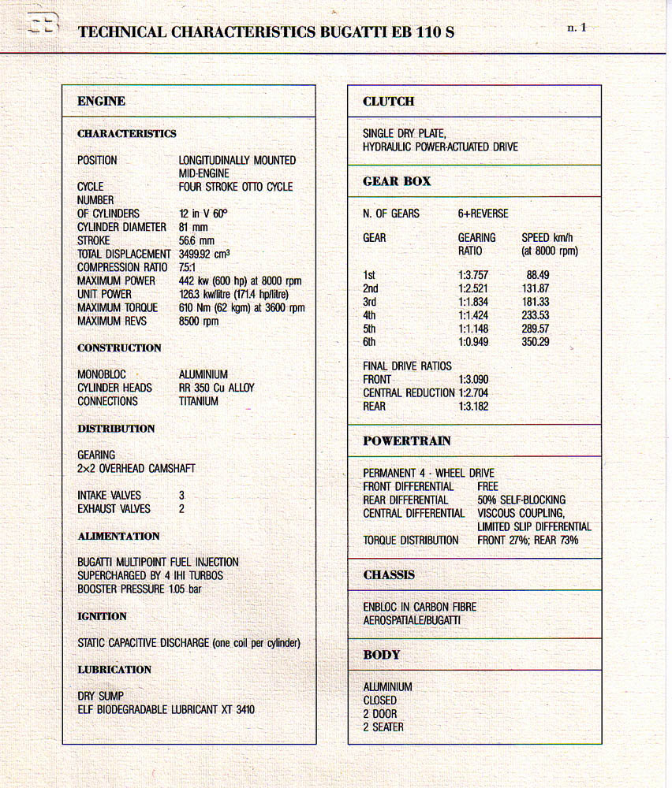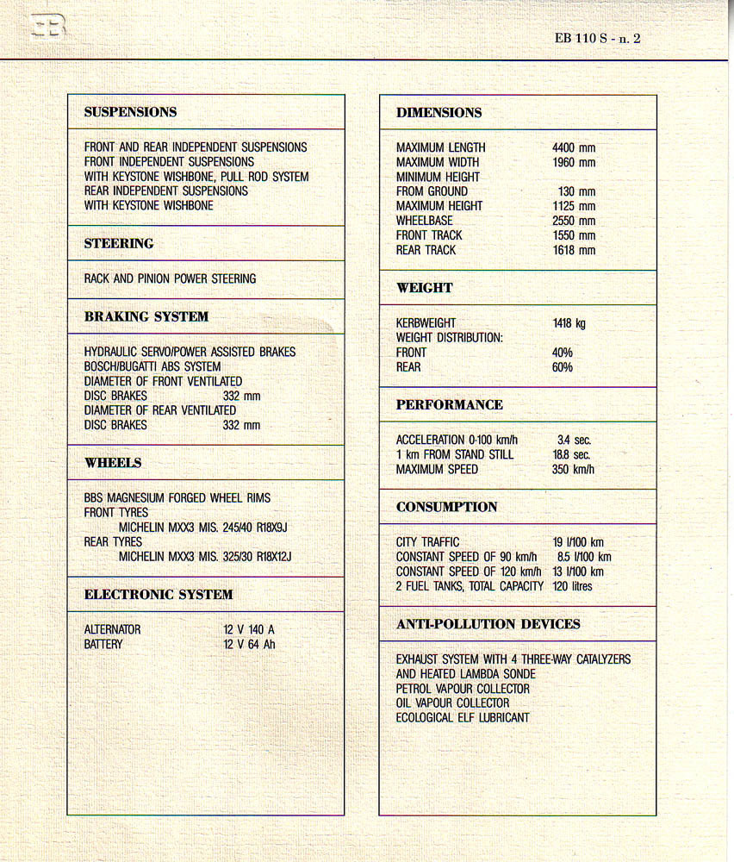

#### GT and S Brochure (early version of SS)

Source: <https://ruoteleggendarie.com/portfolio_page/bugatti-il-sogno-mancato/>

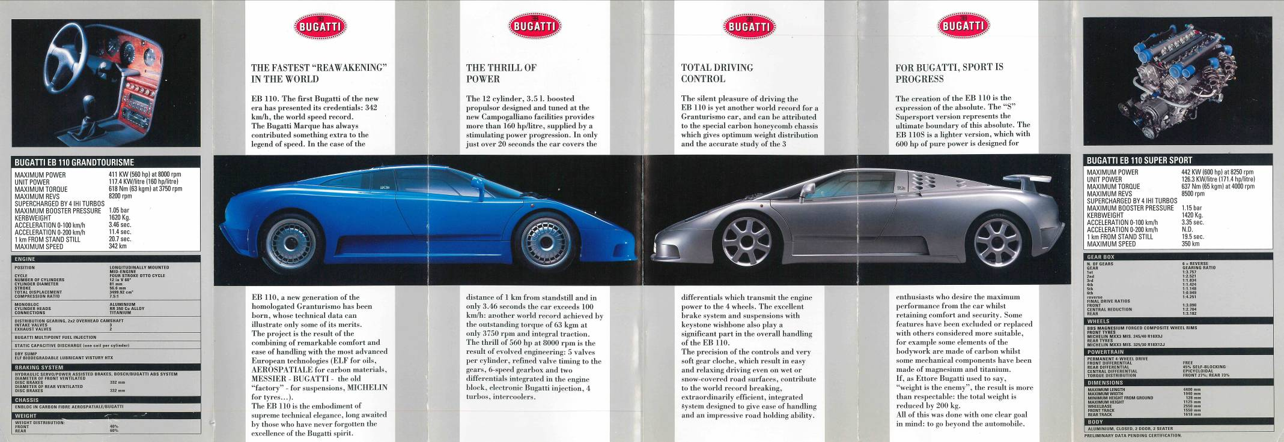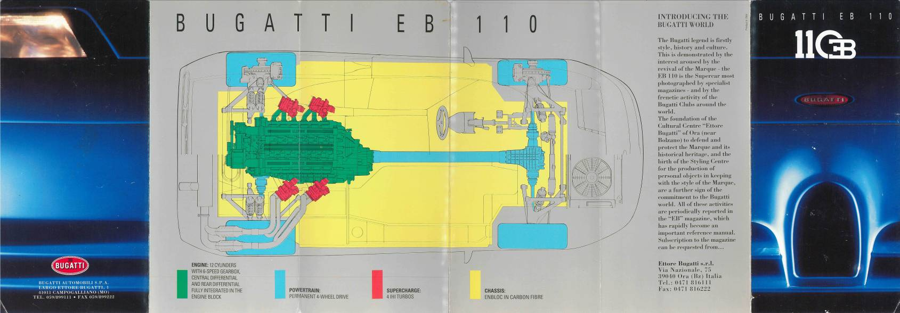

#### Front Susp. schematics 08-10-1993

Source: <http://yo.spc.free.fr/EB110_Registry.htm> (the initial document available from source on request, cannot share it)

The suspension is re-modelled and re-measured in Assetto Corsa wheel centered coordinates by Sergejs:

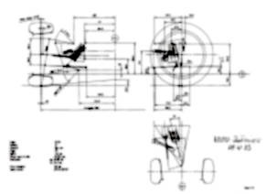

The Solvspace CAD files for suspension geometry are available together with Blender 3D file.

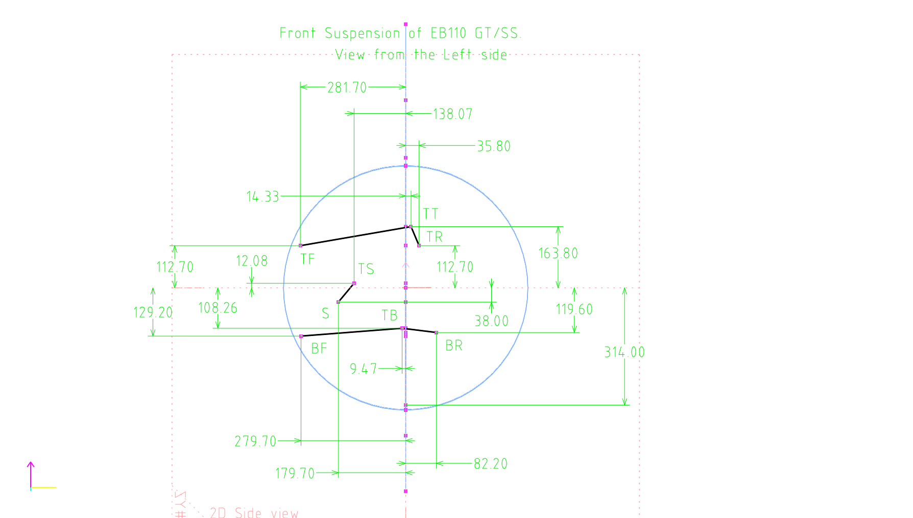

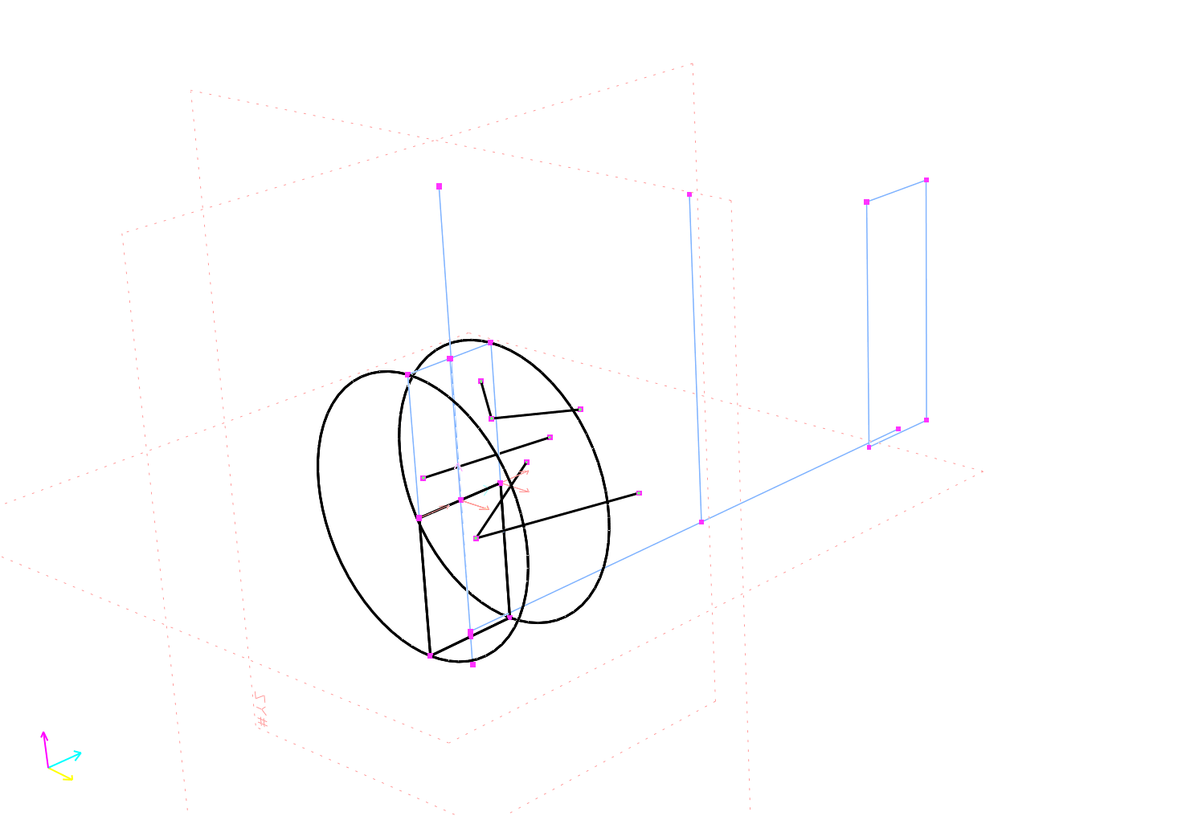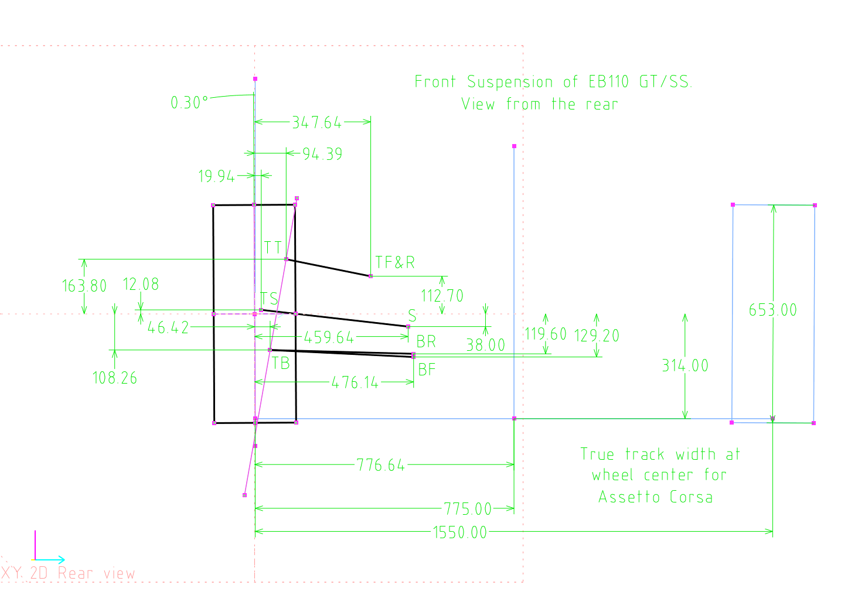

#### Rear Susp. schematics 08-10-1993

Source: <http://yo.spc.free.fr/EB110_Registry.htm> (the initial document available from source on request, cannot share it)

The suspension is re-modelled and re-measured in Assetto Corsa wheel centered coordinates by Sergejs:

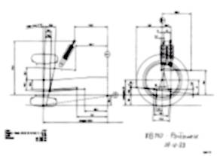

The Solvspace CAD files for suspension geometry are available together with Blender 3D file.

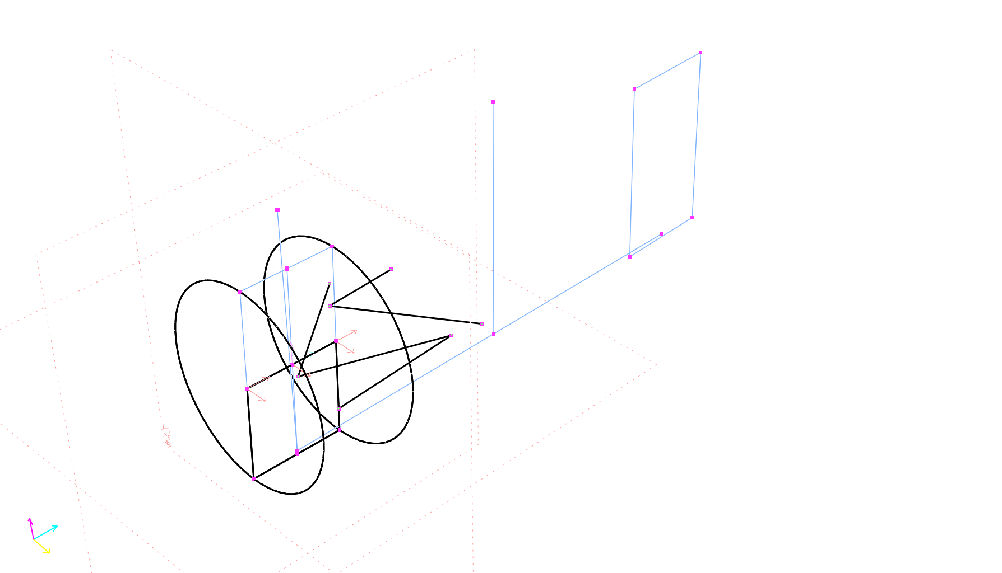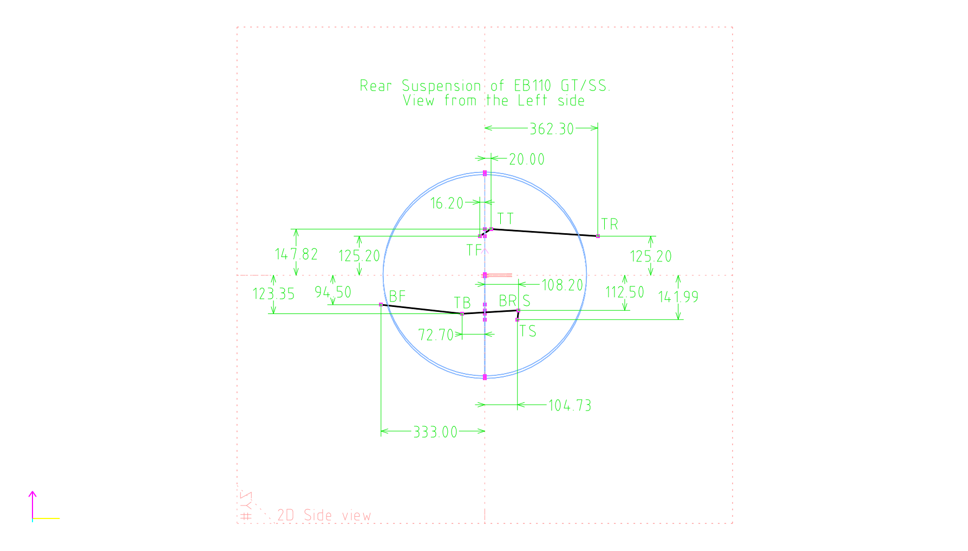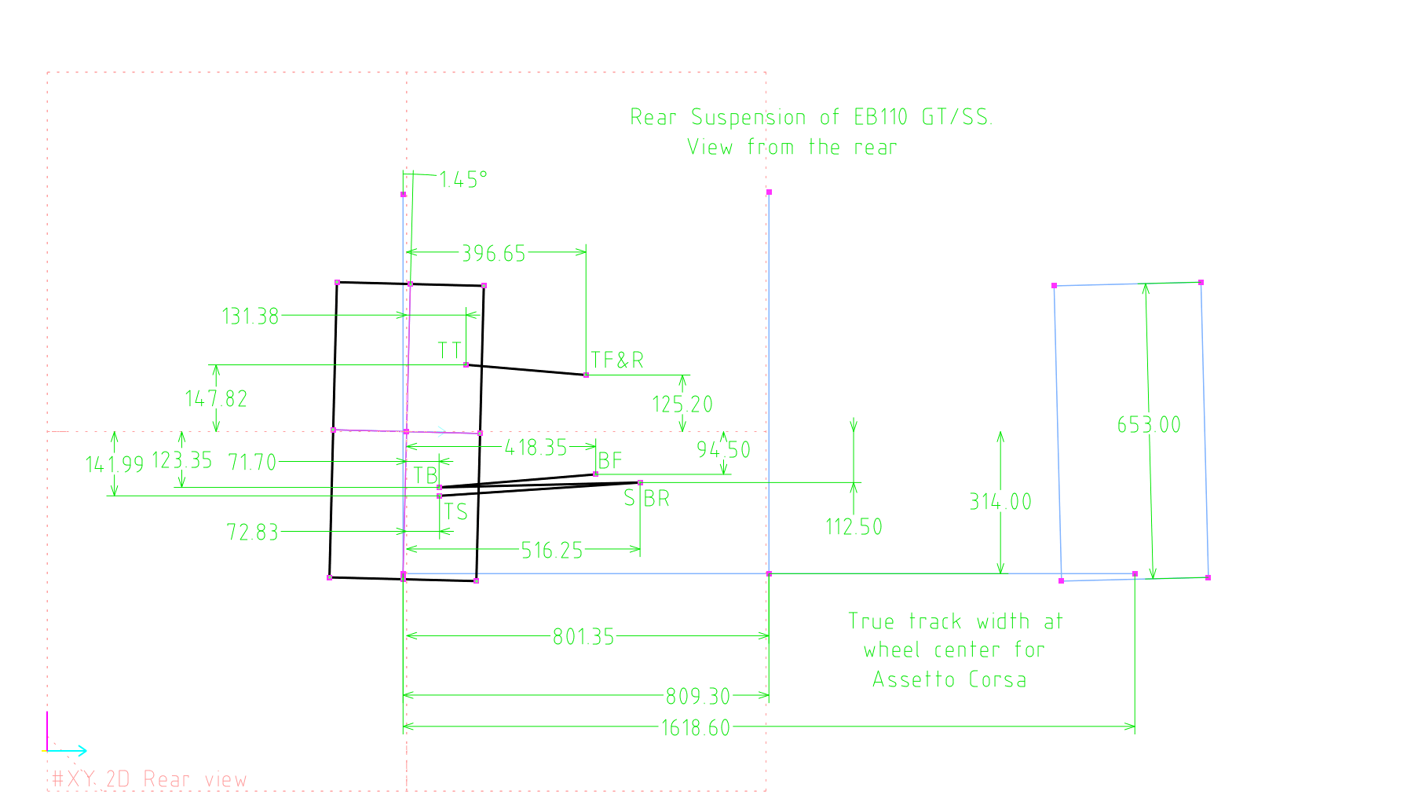

#### Sport Auto, n375

(May 1993, France) Source: <https://www.autotitre.com/forum/Bugatti/EB110/Bugatti-EB110-Magazine-articles-scans-108001p1.htm>

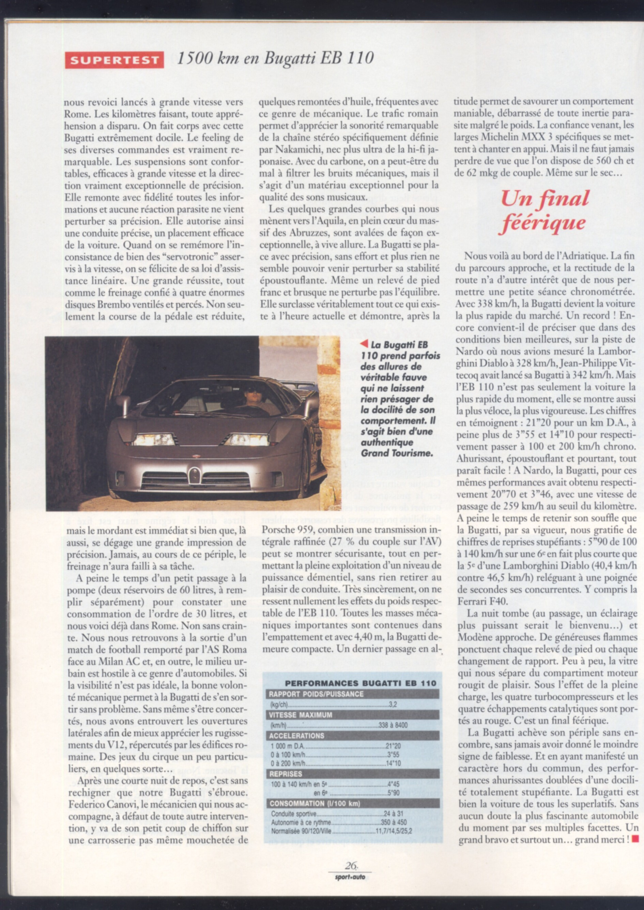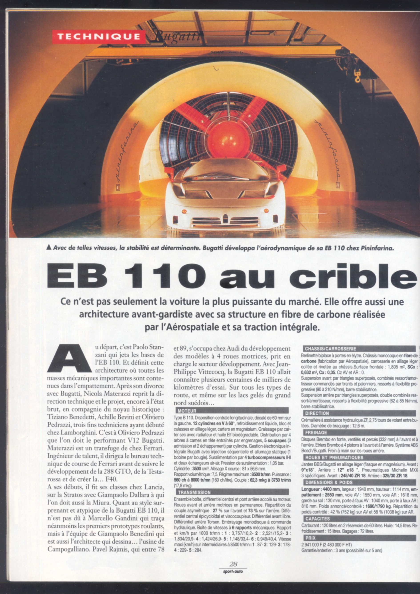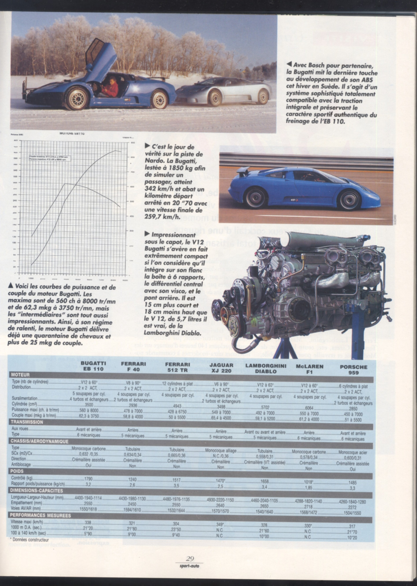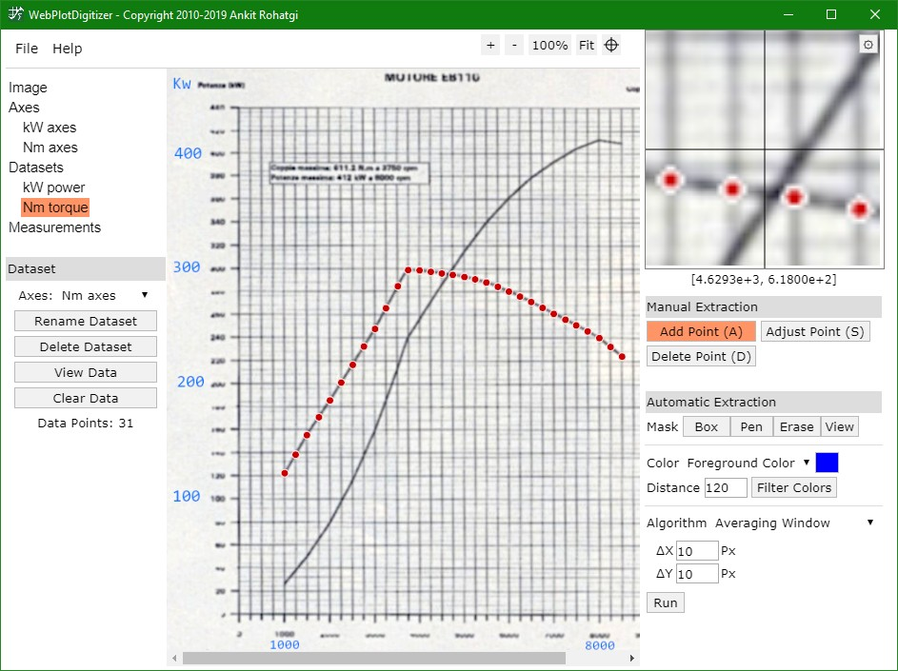

#### Car Graphic, Road Test No.345

(199?, Japan) Source: <https://www.autotitre.com/forum/Bugatti/EB110/Bugatti-EB110-Magazine-articles-scans-108001p1.htm>

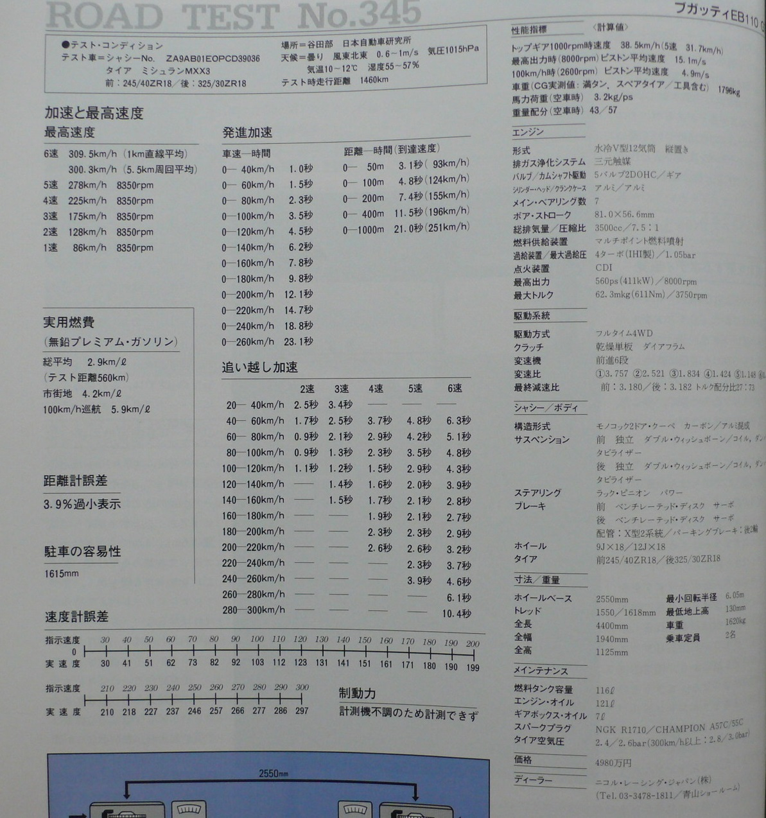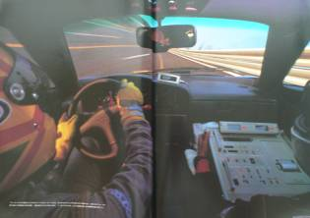

#### Auto Motor und Sport, (May1993)

(Germany) Source: <https://www.autotitre.com/forum/Bugatti/EB110/Bugatti-EB110-Magazine-articles-scans-108001p1.htm>

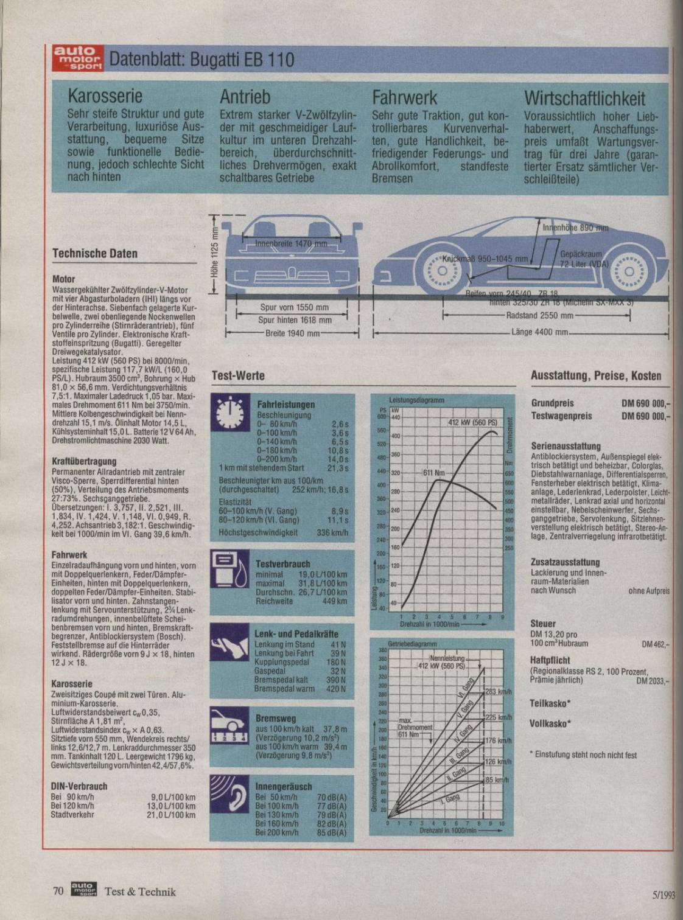

#### Road and Track, (July 1994)

(USA) Source: <https://www.autotitre.com/forum/Bugatti/EB110/Bugatti-EB110-Magazine-articles-scans-108001p1.htm>

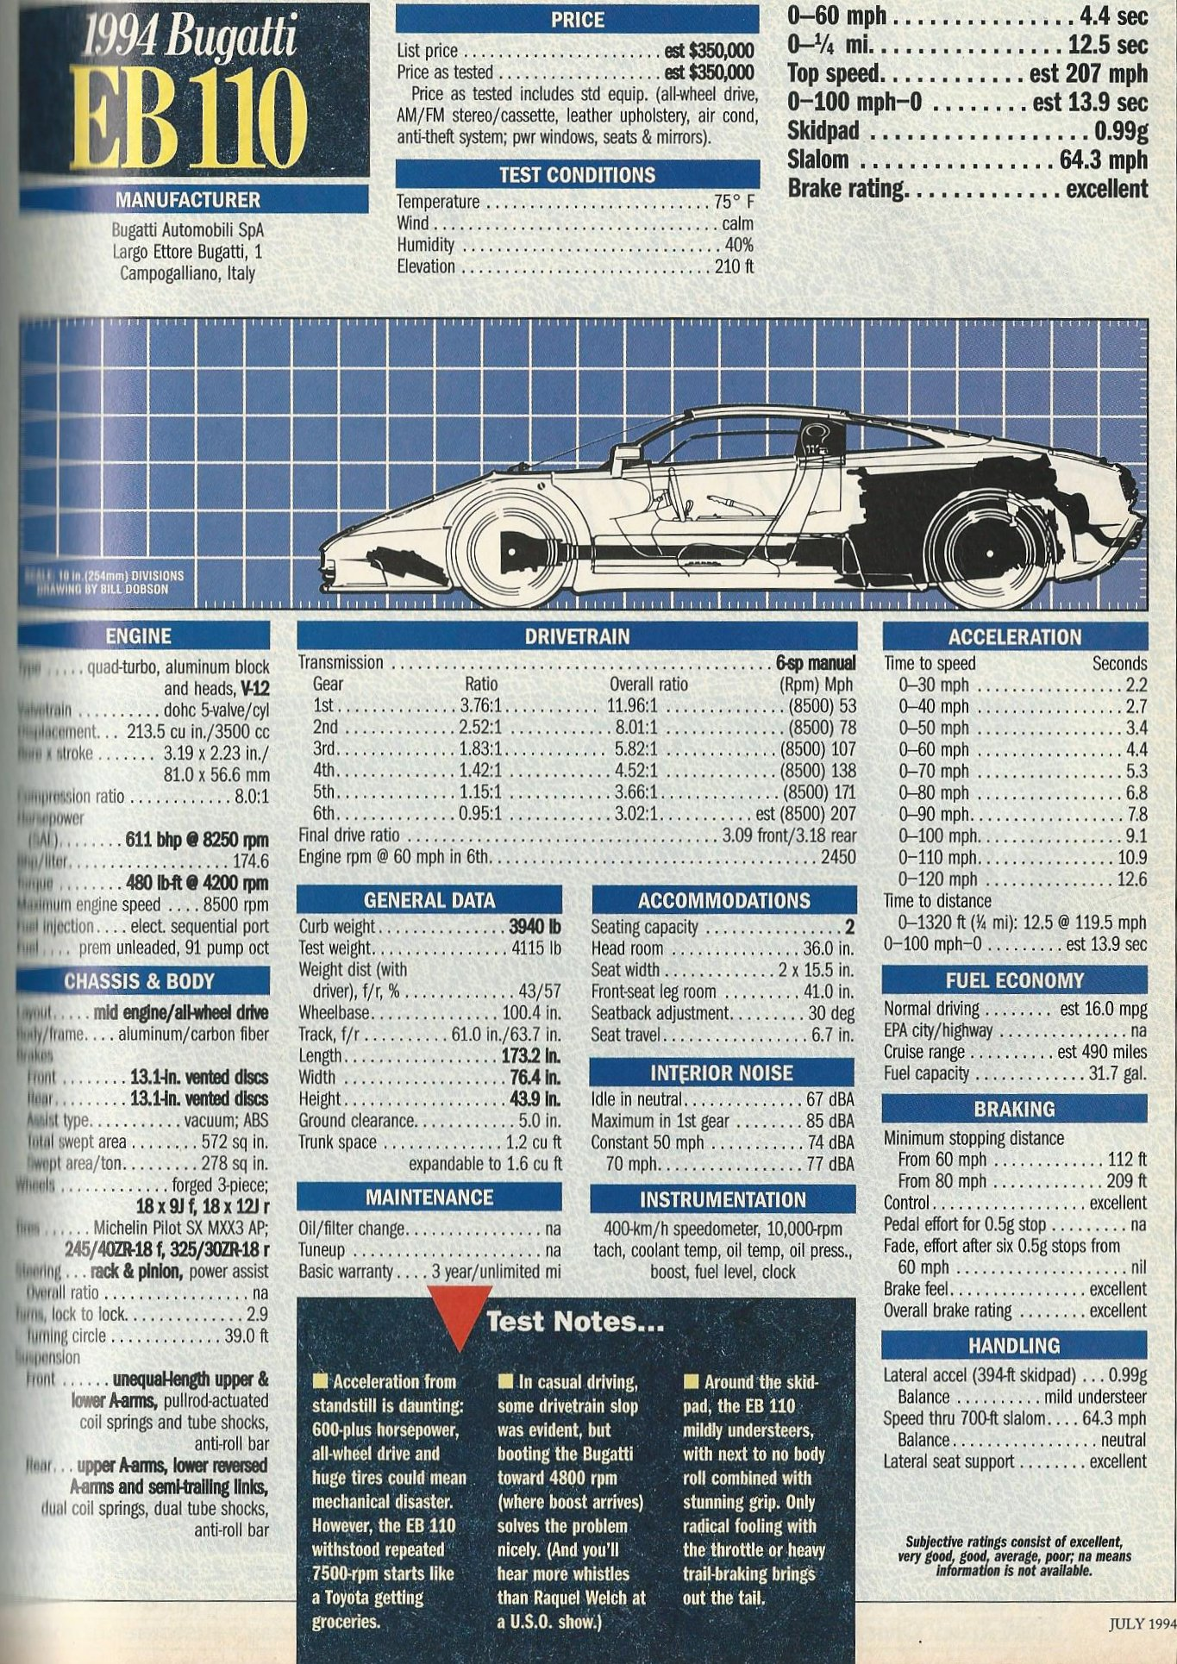

#### Gente Motori, (Aug1993)

(Italy) Source: <https://www.autotitre.com/forum/Bugatti/EB110/Bugatti-EB110-Magazine-articles-scans-108001p1.htm>

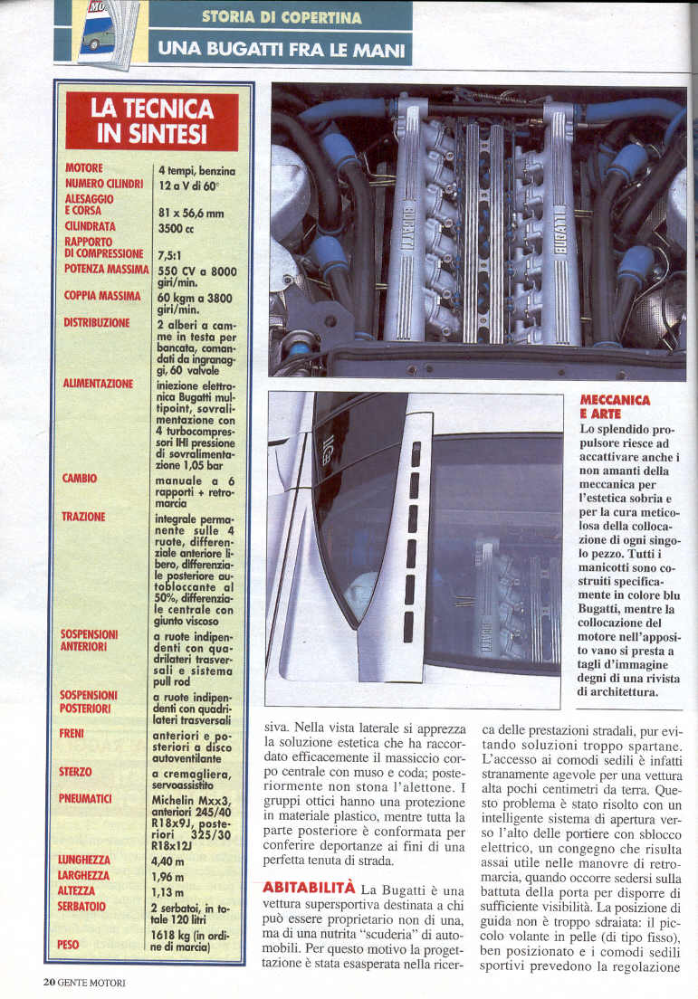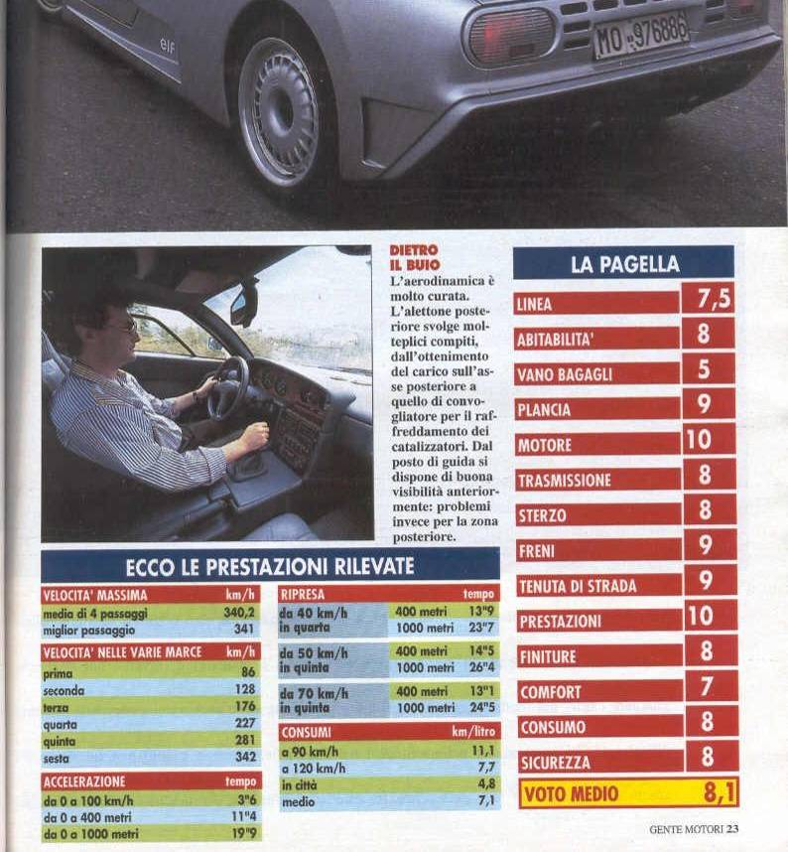

#### CAR magazine (March 1994)

No data. Source: <https://www.autotitre.com/forum/Bugatti/EB110/Bugatti-EB110-Magazine-articles-scans-108001p1.htm>

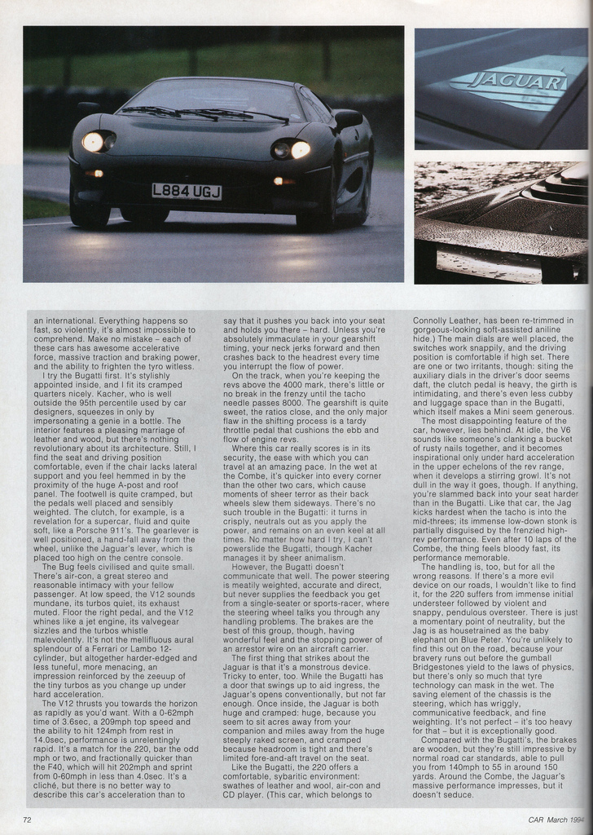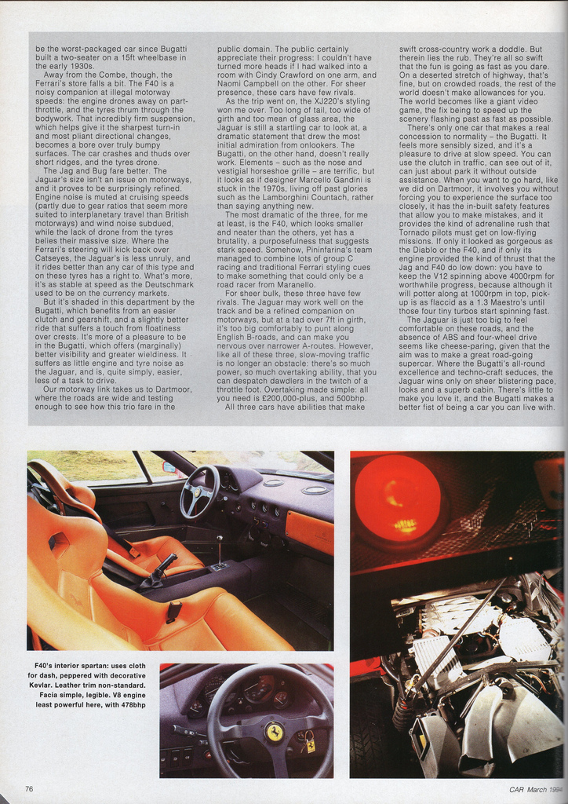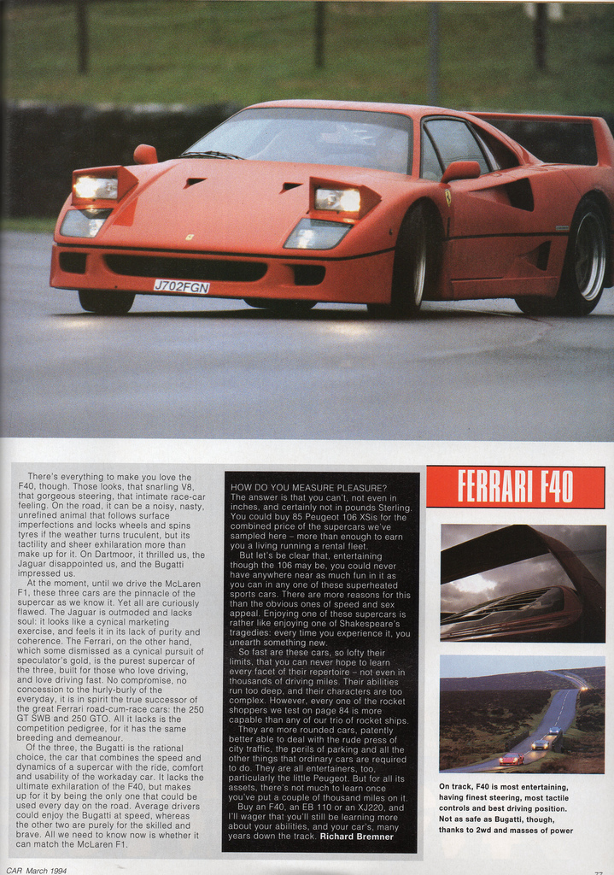

#### Bugatti EB110: a Drivetrain Analyzed

(2018 by DataHunter) Source: <https://supercarengineering.wordpress.com/2018/07/01/the-journey-begins/>

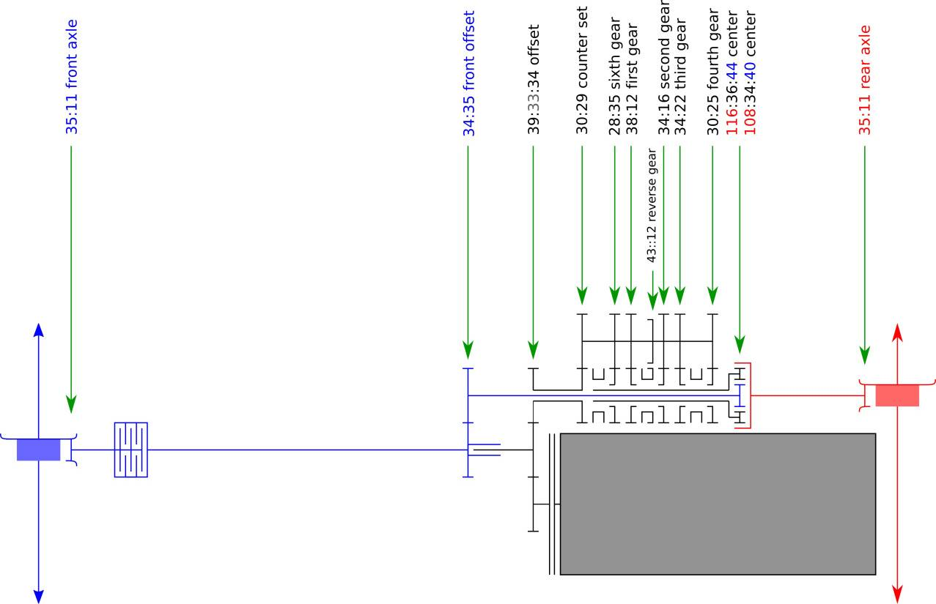

#### Differentials of the 1993 EB110GT (047)

Source: <https://inventory.symbolicinternational.com/vehicles/119/1993-bugatti-eb110-gt>; <https://classiccars.com/listings/view/1183350/1993-bugatti-eb-110-for-sale-in-san-diego-california-92121> & [Bugatti EB110GT - chassis GT047 (free.fr)](http://yo.spc.free.fr/Bugatti%20register/EB110_GT/39047.htm)

